**DAFTAR PUSTAKA**

<http://www.jadibaru.com/android/pengenalan-android-studio-2>

<https://blog.dicoding.com/android-module-5-android-layout/>

<https://developers.google.com/web/fundamentals/codelabs/your-first-pwapp/?hl=id>

<https://idcloudhost.com/pengertian-web-server-dan-fungsinya/>

<https://developers.google.com/web/fundamentals/primers/service-workers/?hl=id>

<https://developers.google.com/web/fundamentals/web-app-manifest/?hl=id>

<https://www.codepolitan.com/mengenal-nodejs-5880234fe9ae3>

<https://id.wikipedia.org/wiki/Npm_(perangkat_lunak)>

<https://rizkimufrizal.github.io/belajar-vue-js/>

<https://firebase.google.com/docs/hosting/?hl=id>

<https://idcloudhost.com/pengertian-web-server-dan-fungsinya/>

LAMPIRAN I (Lembar Asistensi) 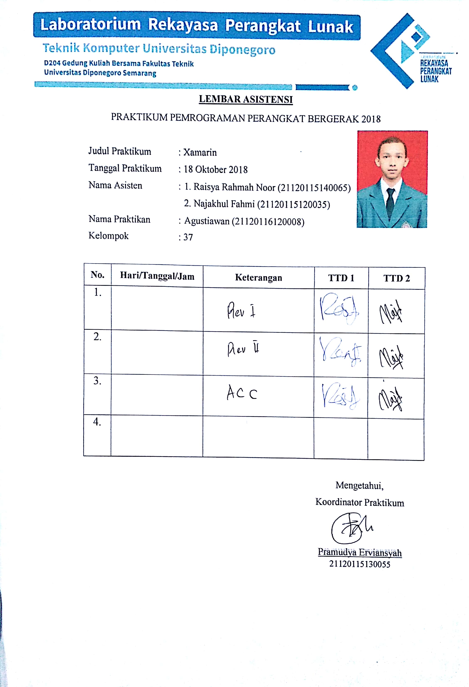 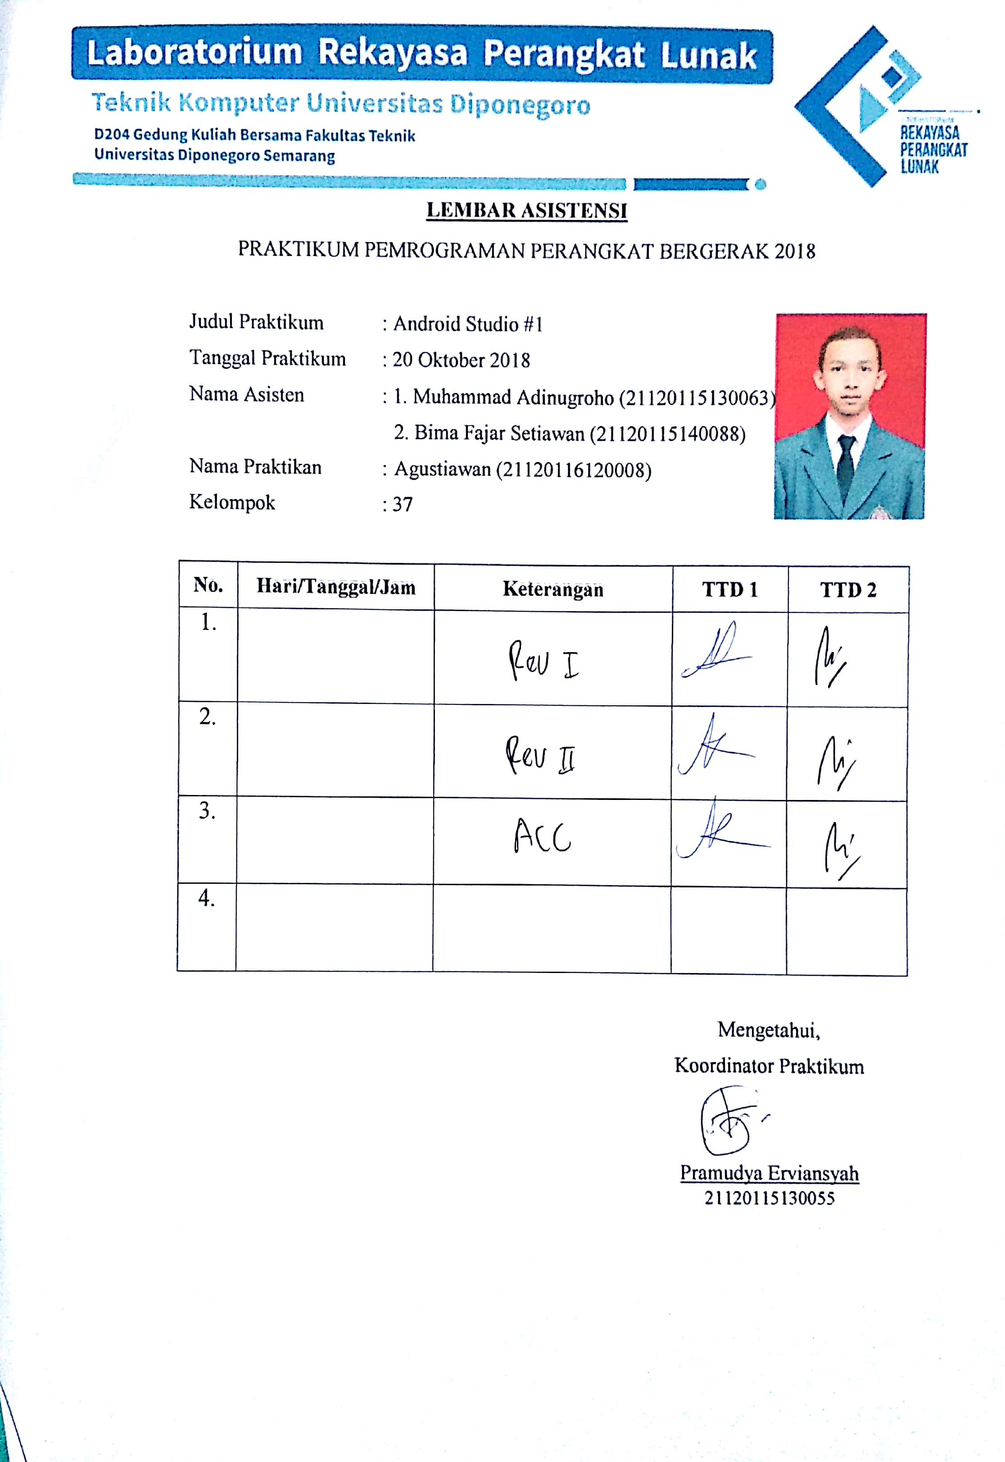 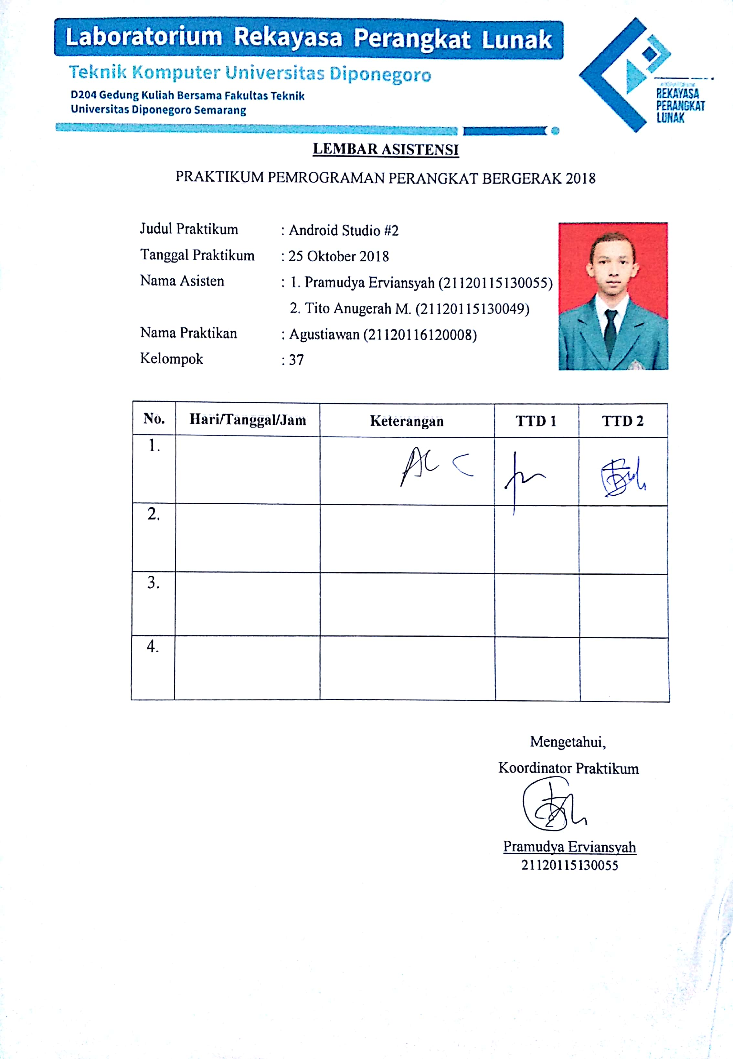 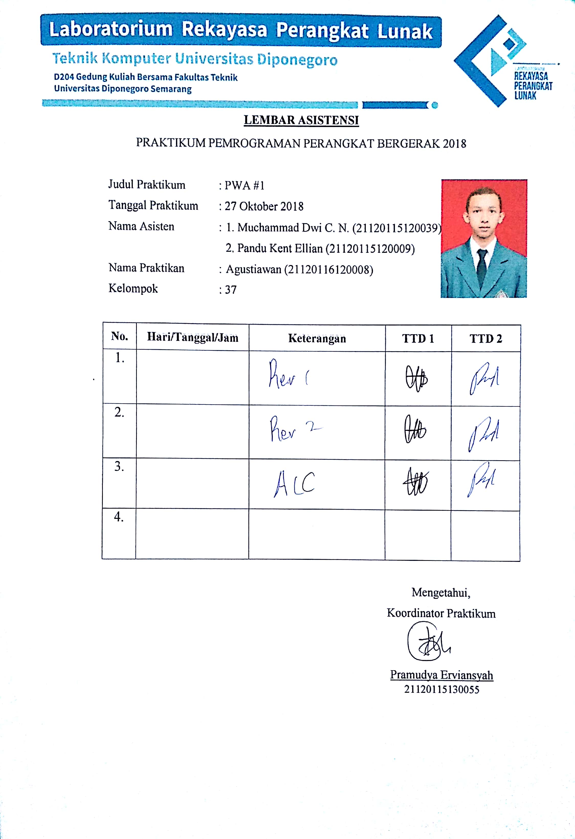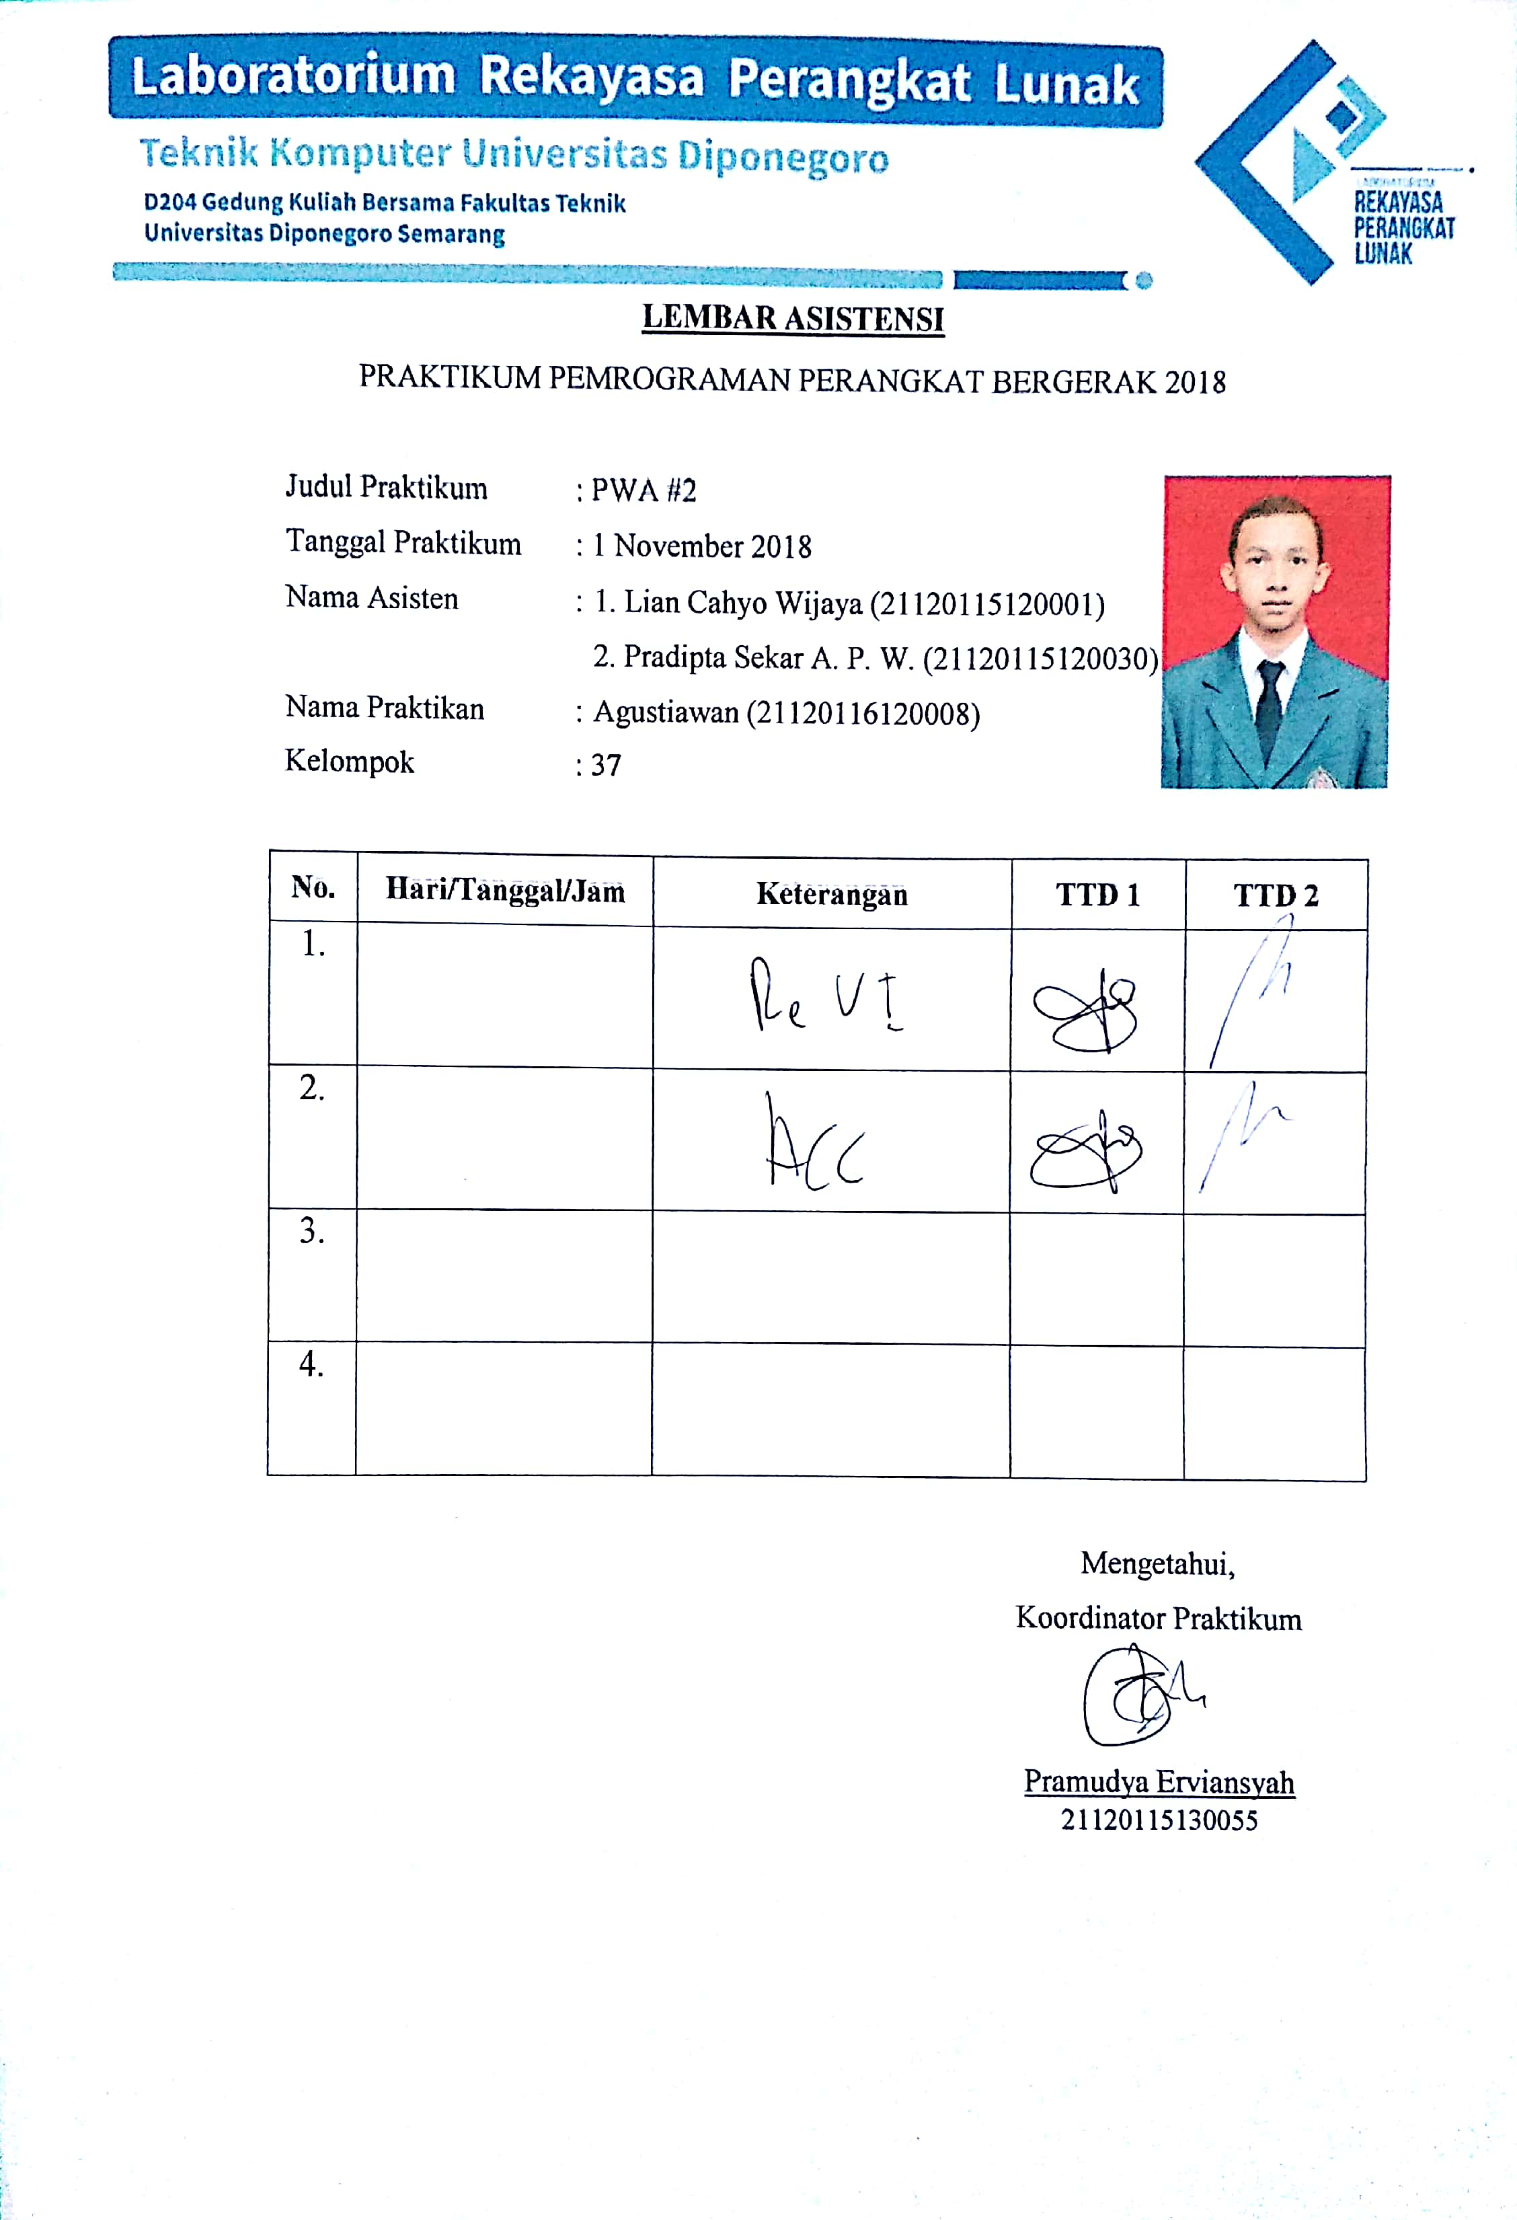 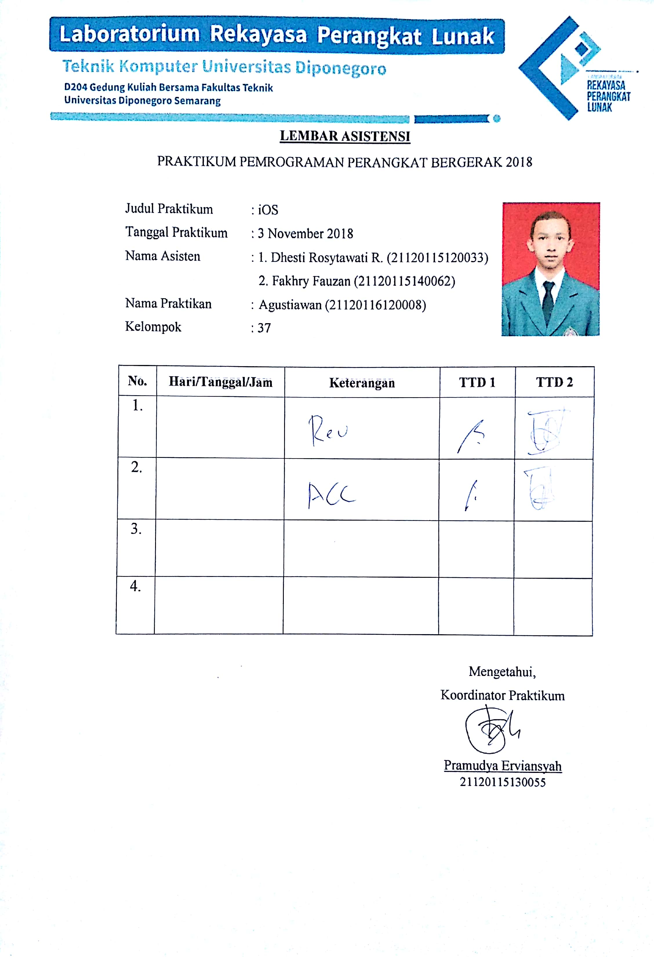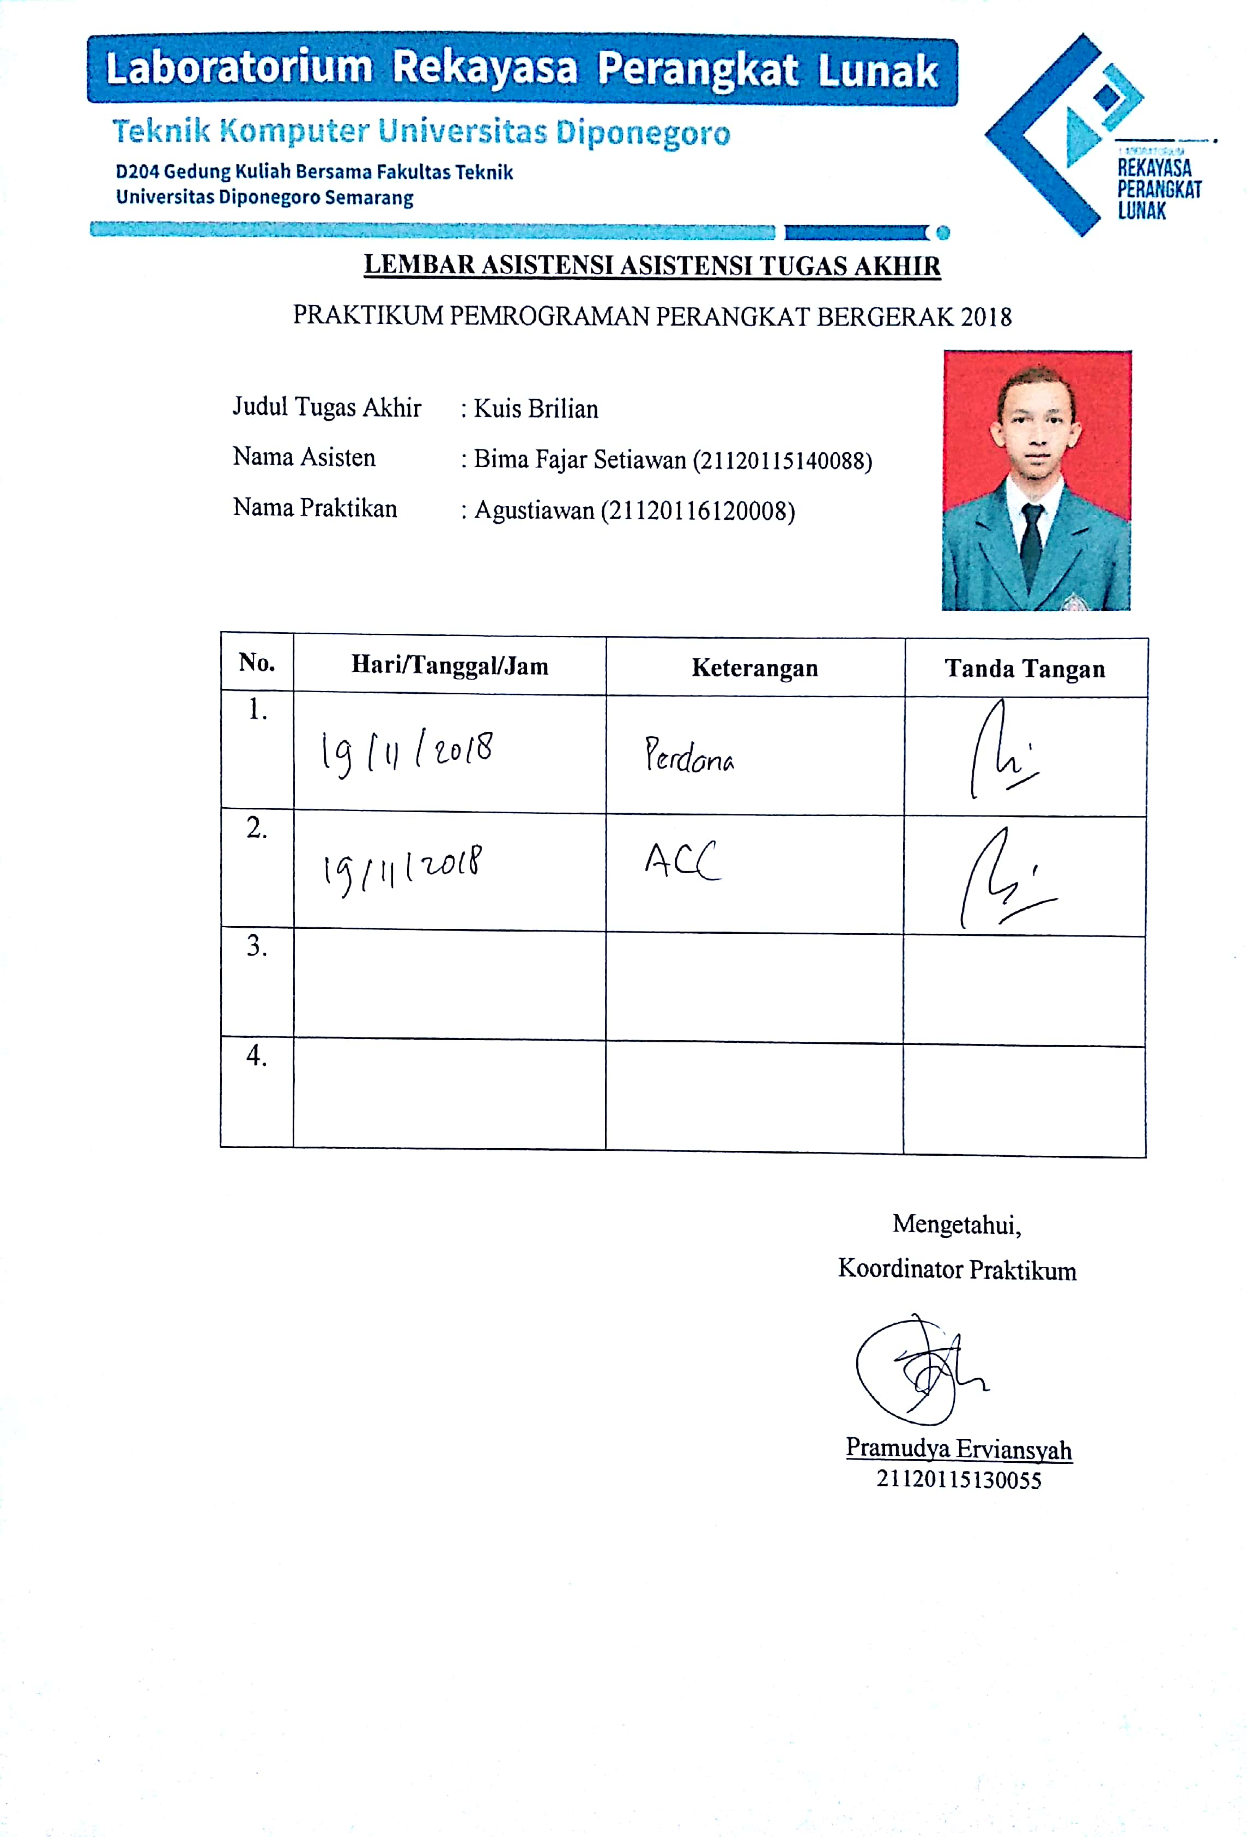

LAMPIRAN II (Tugas Pendahuluan) 